Discussion board

Week 1

* Your preferred name.
* Your current location. (city, state, country, timezone, etc.)
* Do you have any experience with HTML/CSS/JavaScript?
* Do you have any coding experience in other languages?
* Have you taken other design classes at Mason? If so which ones?
* One recommendation for something to do. (movie to watch, album to listen to, hobby to take up, etc.)
* Any other interesting information you think we should know.
* An image that is of you or represents you.
* One question you want everyone to answer.

Hi my name is Rachel Cooper. I live in Fairfax Virginia on the east coast. I have no experience in anytype of coding or other coding experience in other language. My concentration in AVT program is New Media, so I’ve taking different type of design from character design, graphic design, and animation layout design. I just finished watching the new season of Netflix redesign of She-Ra. I would recommend this show to anyone who’s interested in a show that displays modern ideas of humanity and character designs. My dream career is to animator for DreamWorks Animation Studio.

* 1. Which text editor program should we be using for the first exercise?
     + Atom

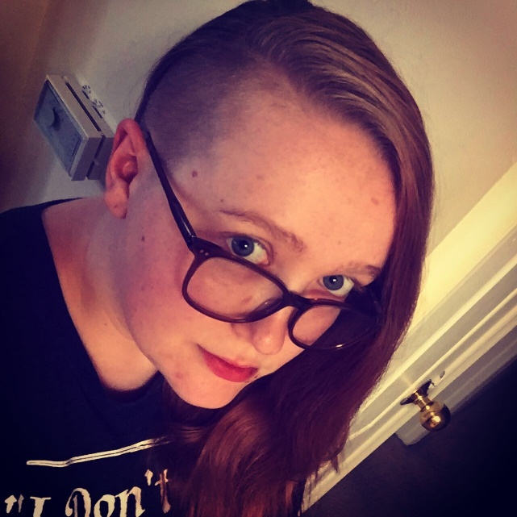

* 1. Micheal McDermott: What is the best food for a hot summer day?
  2. When is a normal time for you to go to sleep?
     + (1) A smoothie from tropical smoothie
     + (2) I go to bed between midnight and 2 am
  3. Lucas Glovas*:* How do you pronounce .gif(the file format)?
  4. And does it TRULY matter one way or the other how someone pronounces it?
     + I think is should be pronounces like gift but without the ‘t’
     + No, it doesn’t matter
  5. Sandy Chuah: What's the weirdest dish you have ever tried?
     + A Godzilla roll
  6. Lauren Day: What's your morning routine? Any podcasts you recommend?
     + I wake up and go to the bathroom to pee, then take a shower.
     + I don’t really listen to podcast. I prefer to listen to music.
  7. JT Young: What everyone’s major is?
     + I have a BFA with a concentration in New Media and minor in Game Design.
  8. Andrew Savino: Do you have any pets?
     + I have four cats: one all black, one tuxedo, one orange, and one mocha colored
  9. Samuel: What is your current favorite music album to listen to?
     + Electric swing
  10. Sina: Who is your favorite graphic designer?
      + I don’t really have a favorite designer
  11. Yusuf: Who is your favorite music artist/band?
      + Black Pistol Fire
  12. Ekwochi: What was your favorite thing to do in quarantine?
      + Watching Netflix and Disney+
  13. What is your favorite bird?
      + *mocking jay*
  14. Ashraf= Is any type of specific art you like?
  15. Rock= Who’s your favorite character from a book, show, game, etc?
  16. Lucas: If you had to pick a superpower what would it be and why?
  17. *Matt: What is your favorite Horror Movie?*
  18. Jenny lam :what's your favorite dessert?
      + Chocolate fudge brownie

Website examples:

(history) <https://broadwaymusicalhome.com/people.htm>

* + - Right tab: use the list and pic as home page
    - Genre type at top

(ticket buy) <https://www.broadway.org/tours>

* + - Broadway troops
    - (on tour)Base the ticket and location on frozen page
    - (nYC) Lion king page

(Netflix similar) <https://www.broadwayhd.com/categories/musicals>

* + - Monthly fee
    - Digital copies of musical films

Week 2

E4- site map+ fav website

E5-Home page= on pager